**Brocade Vepc Automation scripts**

User Guide



**Copyright © 2015 Dell Inc. All rights reserved.** This product is protected by U.S. and international copyright and intellectual property laws. Dell™ and the Dell logo are trademarks of Dell Inc. in the United States and/or other jurisdictions. All other marks and names mentioned herein may be trademarks of their respective companies.

Table of Contents

Revision History: 3

Table of Acronyms 4

1 Introduction 5

2 Pre-requisite Knowledge 5

3 System Requirements 5

4 How to get the scripts 6

5 How to run 7

6 Summary of Scripts 10

7 Execution time of scripts 11

8 Deployment Design 11

9 Login Credentials 12

10 Logs 13

11 Known bugs 13

# Revision History:

|  |  |  |  |
| --- | --- | --- | --- |
| **Revision** | **Date** | **Author** | **Description** |
| 1.0 | Sep 14, 2015 | Abdul Rehman | Initial Version |
| 1.1 | Sep 30, 2015 | Abdul Rehman | Updated Version based on Jermaine’s comments |
| 2.0 | Oct 9, 2015 | Abdul Rehman | Scripts based on the documentation version 4.1 from Brocade |

# Table of Acronyms

|  |  |
| --- | --- |
| **Acronym** | **Description** |
| CPE | Control Plane Engine |
| CDF | Charging Data Function |
| CLI | Command Line Interface |
| CIDR | Classless Inter-domain Routing |
| DPE | Data Path Engine |
| DHCP | Dynamic Host Control Protocol |
| EPC | Evolved Packet Core |
| EMS | Element Management System |
| GUI | Graphical User Interface |
| HTTP | Hyper Text Transfer Protocol |
| IP | Internet Protocol |
| IXIA | A company that provides tools for Network Testing |
| PDN | Public Data Network |
| RAN | Radio Access Network |
| RIF | RAN Interface |
| SDB | Session Database |
| SSH | Secure Shell |
| UDB | User Database |
| URL | Uniform Resource Locator |
| VEPC | Virtual Evolved Packet Core |
| VCM | Virtual Core for Mobile, a Product by Brocade. |
| VEM | VCM Element Management |

# Introduction

VEPC Automation scripts are developed to fully automate the Brocade VCM deployment process in high availability. User needs to perform very minimal configuration, which includes editing some required parameters that are needed for executing the scripts. These parameters vary according to the Openstack deployment in use. Once the user enters those required parameters the deployment process is fully automated. There is no need to later alter any additional parameters during vEPC deployment. This document is intended for anyone deploying Brocade vEPC using the Dell Automation scripts. It will also explain the environment and resources required for the scripts to execute.

# Pre-requisite Knowledge

To be able to use this guide effectively, users need to have a general understanding of operating systems based on Linux kernel and Openstack. Knowledge of the following will be helpful but not required:

* Linux and Openstack command line tools
* Basic knowledge of Python would be helpful but not required

# System Requirements

Two compute nodes are required for running these scripts. The scripts deploy fifteen VMs during vEPC deployment process.

The scripts have tested in the following environment and it is recommended to have this setup before running the scripts:

|  |  |  |
| --- | --- | --- |
| **Openstack Version** | **OS Version** | **Python Version** |
| OpenStack Juno (Fuel 6.1 Deployment) | CentOS 6.5 | 2.6 |

The scripts are also expected to run on the following environments:

|  |  |  |
| --- | --- | --- |
| **Openstack Version** | **OS Version** | **Python Version** |
| Openstack Juno (OPNFV Arno Deployment) | Ubuntu 12.04 | 2.7 |
| Openstack Juno (Wind River Deployment) | Wind River Linux | 2.7 |

Following hardware resources are required on each Compute Node:

|  |  |  |  |
| --- | --- | --- | --- |
| **Node** | **Memory** | **Storage** | **Logical CPUs** |
| Compute 1 | 64GB | 640GB | More than 48 |
| Compute 2 | 64GB | 640GB | More than 48 |

The EMS instance consists of standard Openstack flavor “m1.large” which has the following specifications:

|  |  |  |  |
| --- | --- | --- | --- |
| **Flavor** | **Memory** | **Storage** | **Logical CPUs** |
| m1.large | 8GB | 80GB | 4 |

All other instances except EMS consists of standard Openstack flavor “m1.medium” which has the following specifications:

|  |  |  |  |
| --- | --- | --- | --- |
| **Flavor** | **Memory** | **Storage** | **Logical CPUs** |
| m1.medium | 4GB | 40GB | 2 |

The script will create availability zones for two compute nodes. The names of the zones are ‘Compute 1’ and ‘Compute 2’. There are no specific hardware requirements for Control nodes, except they need to have enough resources available to work with compute nodes.

# How to get the scripts

In order to obtain the scripts they must be downloaded. To download the scripts, log in to Dell Box account using the URL <http://app.box.com/>.

**Note:** If you don’t have Box account please contact your dell representative.

After login process is complete, go to the directory NFV/vnf/partner_brocade/ and download the file:

*vEPC_final.tar.gz*

This contains all files for running vEPC scripts and a checksum.txt file containing checksum of *vEPC.tar.gz.*

SSH into the active control node and copy the *vEPC_final.tar.gz* file in /root/ directory.

After copying *vEPC.tar.gz* file on control node, calculate its checksum using command:

*md5sum vEPC_final.tar.gz*

Verify the value printed on CLI with value given in *checksum.txt* file to be sure that tar file is not corrupted.

Now run the command to untar the vEPC.tar.gz:

tar –zxf vEPC_final.tar.gz vEPC/

After the untar completes change the directory by entering the following command:

cd vEPC_final

# How to run

To execute scripts, SSH into the CLI of active control node and go inside vEPC directory. Before running the scripts, user need to edit the “creds.txt” file provided in vEPC scripts directory based on the required parameters explained below for successful execution of deployment scripts.

Values should be entered in inverted commas as currently entered as a sample in creds.txt file shown in Figure 1, the order and format of parameters should not be changed.

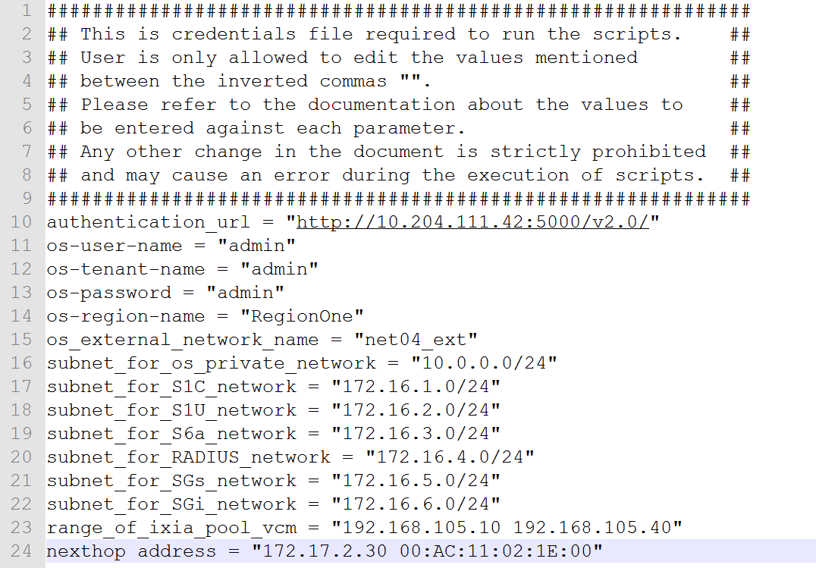

Figure 1: Sample values of creds.txt file

1. authentication_url = “OS_AUTH_URL from openrc/keystonerc_admin file located at /root/ openrc/keystonerc_admin in Control Node”
2. os-user-name = “OS_USERNAME from openrc/keystonerc_admin file located at /root/ openrc/keystonerc_admin in Control Node”
3. os-tenant-name = “OS_TENANT_NAME from openrc/keystonerc_admin file located at /root/ openrc/keystonerc_admin in Control Node”
4. os-password = “OS_PASSWORD from openrc/keystonerc_admin file located at /root/ openrc/keystonerc_admin in Control Node”
5. os-region-name = “RegionOne” You can get this value by entering the following commands on active control node:

*keystone endpoint-list*

1. os_external_network_name = "net04_ext"

External network name is the name of the External network in Openstack used for external communication.

**Note:** This network should already exist in Openstack networks and if it isn’t created during deployment, please create this before executing the scripts.

1. subnet_for_os_private_network = "10.0.0.0/24"

Enter the subnet value for private network which will be created for communication between all VCM VMs.

1. subnet_for_S1C_network = "172.16.1.0/24"

Subnet value for S1C network is the value of subnet to be assigned to S1C network for connection with RIF.

1. subnet_for_S1U_network = "172.16.2.0/24"

Subnet value for S1U network is the value of subnet to be assigned to S1U network for connection with DPE.

1. subnet_for_S6a_network = "172.16.3.0/24"

Subnet value for S6a network is the value of subnet to be assigned to S6a network for connection of UDB with HSS.

1. subnet_for_RADIUS_network = "172.16.4.0/24"

Subnet value for RADIUS network is the value of subnet to be assigned to RADIUS network for connection of CDF with RADIUS.

1. subnet_for_SGs_network = "172.16.5.0/24"

Subnet value for RADIUS network is the value of subnet to be assigned to RADIUS network for connection of RIF with MSC.

1. subnet_for_SGi_network = "172.16.6.0/24"

Subnet value for RADIUS network is the value of subnet to be assigned to RADIUS network for connection of DPE with Internet GW.

1. range_of_ixia_pool_vcm = "192.168.105.10 192.168.105.40"

Specify range of IP addresses which will be used to assign to UE. First IP specifies the start of pool and second IP address specifies the end of pool.

1. nexthop address = "172.17.2.30 00:AC:11:02:1E:00"

It’s the IP address of outbound server for traffic towards internet, if using router then enter IP address of router which will NAT the IP and forward it to the internet.

After successfully updating the above parameters, following are the commands to run the vEPC scripts.

1. To deploy vEPC, run “python vEPC_deploy.py”
2. To terminate vEPC, run “python vEPC_termination.py”

# Summary of Scripts

There are total of 2 scripts for vEPC deployment process, each script performs a specific operation:

1. **vEPC_deploy.py**

* This script deploys vEPC VCM components in high availability. Total of 15 instances are deployed in the form of VCM-1 (7 instances), VCM-2 (7 instances) and 1 instance for EMS and 7 Networks namely VCM_Net, S1C, S1U, S6a, RADIUS, SGs and SGi.

1. **vEPC_termination.py**

* Terminates the all components of vEPC and prompts the user if it wants to delete EMS, aggregate groups and glance images of VCM and performs the action based on the user input

Detailed functionality of each script is explained in the document name “vEPC Automation Scripts Design Reference” along with diagrams for better understanding without going deeper into the inner details of APIs and functions used to perform such tasks.

# Execution time of scripts

Depending upon the computational power, all the four scripts have variant execution time. Approximate time of completion is stated below:

1. Initial deploy scripts takes 30-40 minutes
2. vEPC termination script takes 7-10 minutes

# Deployment Design

VCM components are deployed in high availability and each component requires the creation of 7 instances. Each instance has different requirements of ports and networks attached to it. Following diagram shows the networks created during deployment and VMs associated with it:

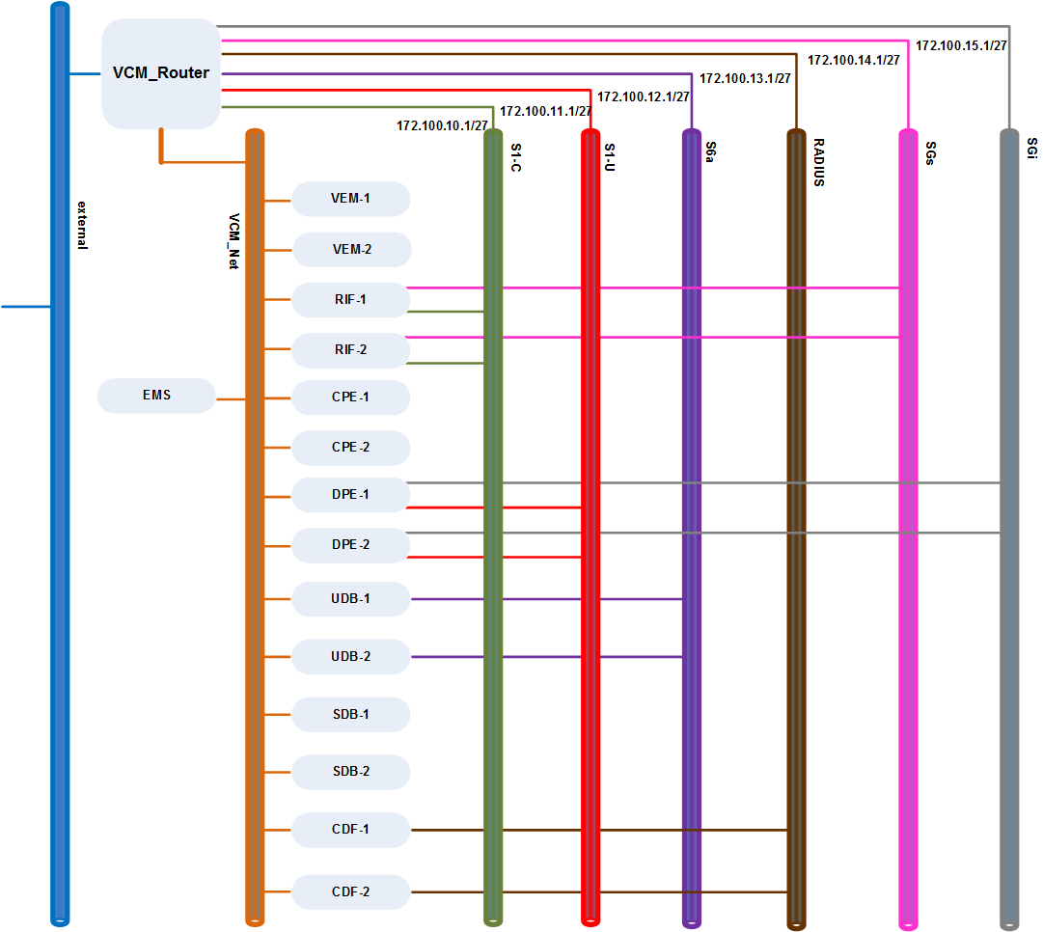

Figure : Network Layout and Connectivity with VMs

# Login Credentials

To SSH into VCM and EMS instances use the following credentials:

Username: root

Password: root123

To login to the EMS GUI, use the following credentials:

Username: admin

Password: Root1234

# Logs

All the scripts generate logs during execution. To see the logs generated during the execution of scripts, go into the /vEPC/logs/ directory. It contains a total of 8 files, 2 for each script; one file is for activity log i.e. the total flow of script in which it deploys VCM components and the second is error log in case if any error occurs during the execution of script.

1. deploy_date_time.log and deploy_error_date_time.log
2. terminate_date_time.log and terminate_error_date_time.log

# Known bugs

If you see any of the following bugs in log files or CLI please refer to the resolution/possible reason of the bug to know the actual cause of bug.

|  |  |  |
| --- | --- | --- |
| **Sr. #** | **Bugs** | **Resolution/Possible reason** |
| 1. | Unauthorized: The request you have made requires authentication. (HTTP 401) | This error usually occurs when the authentication URL, OS_USERNAME, OS_PASSWORD or OS_TENANT_NAME entered in creds.txt doesn’t match with the values of keystonerc_admin/openrc file. Please double check the values and try running the scripts again. |
| 2. | novaclient.exceptions.NotFound: No more floating ips in pool. (HTTP 404) | This error usually occurs when there are no more floating IPs available in the pool to assign to instances. Please increase the number of floating IP pool and then re-try. |
| 3. | Floating IP assignment error. Retrying...  Error: Connection to neutron failed: HTTPConnectionPool  Request timed out. (timeout=30) (HTTP 400) | This error is generated when keystone is unable to make a connection with neutron or neutron server is not responding. Please make sure your neutron/nova server are active and verify by using following commands:  neutron net-list  nova service-list |
| 4. | BadRequest: No nw_info cache associated with instance (HTTP 400) | This error occurs because of race when associating floating IP to fixed IP. Originally, the fixed IPs are associated and "virtual_interface_id" is updated and saved to the DB at a later time. When floating IP is tried to be allocated before the update in database, it can cause this error. |
| 5. | No valid host was found. | This issue usually occurs because of not enough resources available to deploy the instances. There is a resource check function which gives warning to the user if the resources are not enough and if user still continues deployment this could lead to an error. |
| 6. | EMS status Failed | Initial Deployment script deploys the VCM-EMS and tries to start the EMS service, if you see the FAILED status on CLI try to login using the URL provided as the EMS sometimes show FAILED status while it’s still working. This is probably the issue with EMS image provided by Brocade. |